LOCATION, DETECTION AND NAVIGATION OF UNMANNED VEHICLES

Abstract: Various approaces for sensor orientation were studied to obtain the optimal configuration. An algorithm was developed using Machine Learning to find the location of the vehicle using distance measurements obtained from several sensors placed around it. A Deep Learning algorithm was also developed to detect the objects through a webcam placed on the UMV.

1. Sensor orientation for obtaining most accurate range values

Ultrasonic sensors were used to obtain the distance of the vehicle from the recievers. 12 sensors were used for this purpose. These sensores were kept at a distance of 5.5 metres apart such that there were 3 sensors on each side. This gave us a more accurate location of where the vehicle is. We tried various methods of sensor orientation to figure out the method that had maximum sensors in range at any given point.

We decided to make half the sensors long range and the other half short range such that the long range sensors range from 6m to 17m and the short range sensors range from 1m to 9m.

In the first approach, we placed short range sensor between two long range sensors on the all sides. When plotting such a configuration it was found that there were many areas in the plot where very few sensors were in range of the vehicle. This conclusion gave us more insight to obtain a better form of orientation.

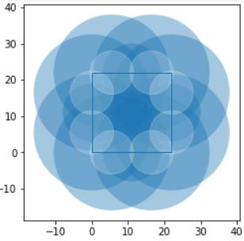
Sensor orientation Type-1

In the second approach, we placed the long and short range sensors in alternate fashion. When the following configuration was plotted, we found a much better plot where 4 or more sensors were found to be in range thereby providing us with better range values for location calculation.

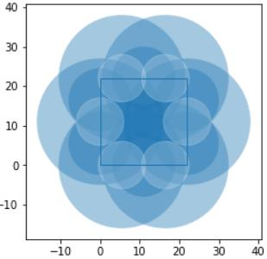
Sensor orientation Type-2

2. Range Estimation from sensor range data

The range measurements obtained from the sensors are corrupted by noise such as multipath reflection, atmospheric condition etc. To estimate the range close to the true value certain estimation algorithms were implemented.

The N - sample mean of the range measurements were taken to minimize the uncertainty. This approach is inefficient in removing the outliers caused by external factors.

Due to this reason, a Machine Learning (ML) model called linear regression was used to improve the accuracy of the range measurements. Linear regression model forms a relationship between the obtained sensor data and the true value.
A dataset of range measurements for every 1.5mts was acquired and plotted vs true value, where the slope of the line is given by:
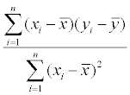
It was found that the model helped us achieve better values at the extreme ranges provided by the ultrasonic sensor.

3. Position Estimation from the obtained range measurements

There tend to be small deviations from the actual measurements inspite of passing the values through the Linear Regression model. Another Machine Learning approach called k-means clustering was used for accurate position estimation.

In this method, every two range values from the receivers are taken and the two points of intersection are obtained as the two circles provides a maximum of two intersection points. From these two obtained points, we know that the unmanned vehicle is located closer to one of these points.
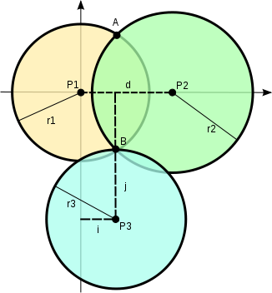
Intersection points from various groups of range measurements

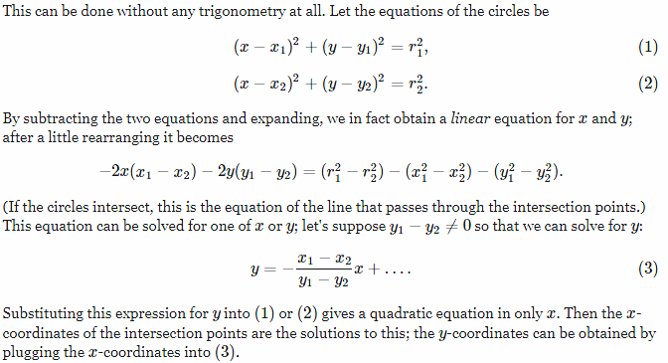

From these clusters obtained, the center of the largest cluster is taken to be the location of the unmanned vehicle.

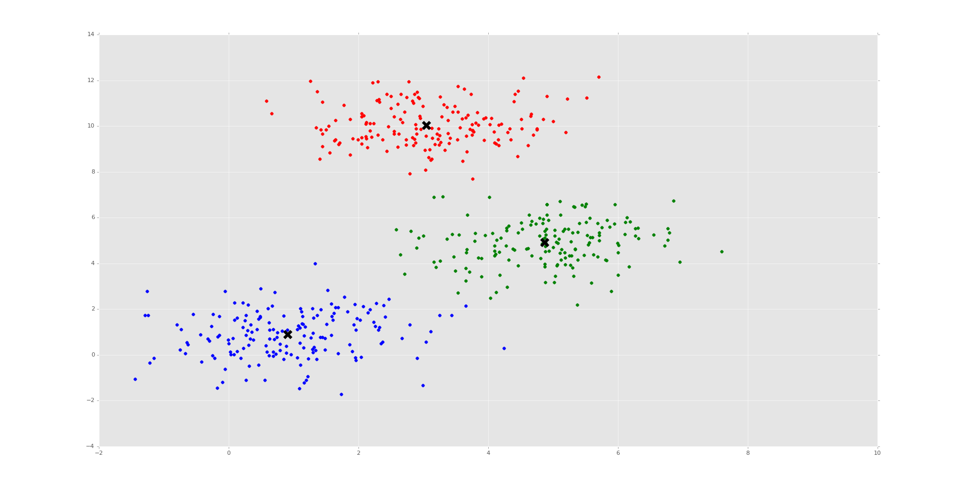
Visualization of k-means clusterning

The circles have the ultrasonic reciever locations as their center and the range measurements as their radius. So, from the list of range measurements, various sets of points are obtained. These points are passed through the k-means clustering algorithm and the points obtained are plotted and divided into groups depending on the distance of the point from the center.

4. Object detection for vehicle navigation

Object detection was essential for vehicle navigation as the type of object infornt of the unmanned vehicle tells how big a deviation needs to be taken. Thus, to detect the object, image processing using opencv and deep learning using tensorflow was used. A tensorflow object detection API was created to detect the presence of UMV’s and other objects.

Methodology:
- Collected a few images that contained pictures of the unmanned marine vehicle.
- Annotate/label the images using this program. This process was used to draw bounding regions around the object(s) in the image. The program automatically creates an XML file that describes the object(s) in the pictures.
- This data was then split into train/test samples.
- TF Records were generated from these splits.
- Used a mobilenet configuration file for developing the model
- Training the model
- Exported graph from new trained model
- Used the You only Look once .config along with the created model for more accurate detection of objects.
- Saved the model as a protobuf file for direct imlpementation and ran the model on custom objects in real time.
Outputs obtained: (pink box: boat; blue box: bird etc.)
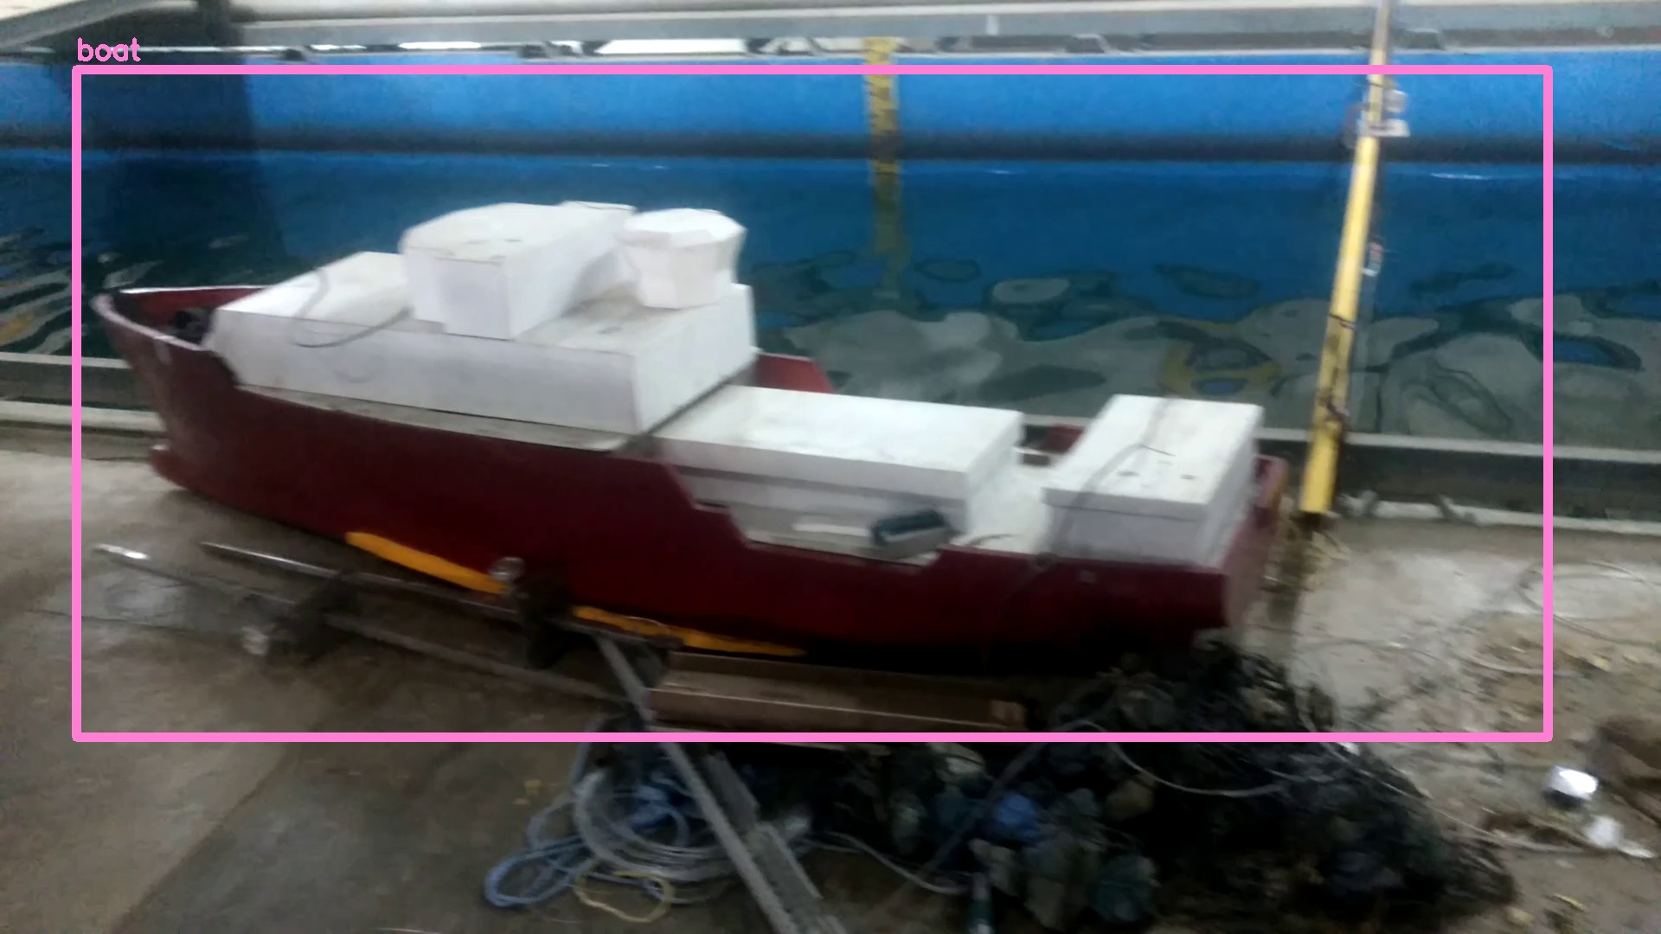
Sample 1
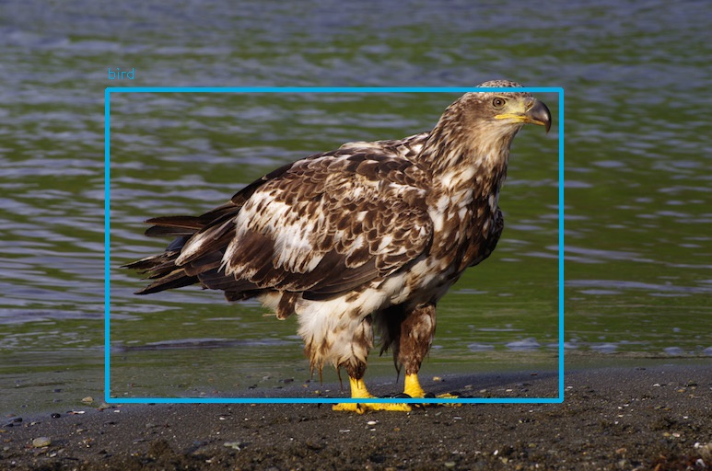
Sample 2
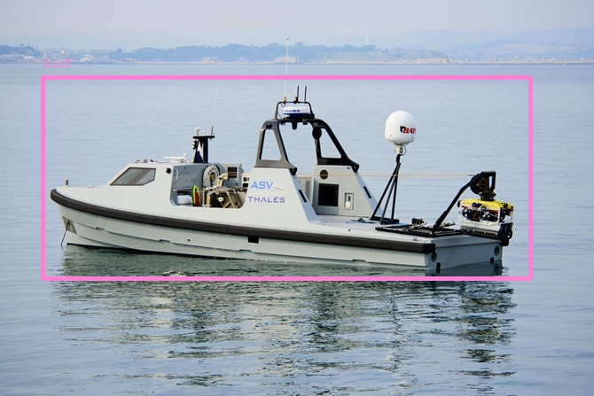
Sample 3

Future Work
- Creation of python TCP module to transfer data from LabView to Python.
- Integration of developed model with hardware components.
- Imporovement of object detection accuracy.
- Creation of Navigation algorithm for the unmanned marine vehicle to traverse from one point to another without any external aid.

References
- F. Pedregosa et al., “Scikit-learn: Machine learning in Python.” J. Mach. Learn. Res., vol. 12, pp. 2825–2830, 2011.
- Darkflow for object detection model - https://github.com/thtrieu
- Hands-On Machine Learning with Scikit-Learn and TensorFlow - Aurélien Géron
- Tensorflow API for creation of object detection models - https://github.com/tensorflow
- Understanding various approaches and development of plots in Machine Learning - https://pythonprogramming.net
- Program that creates XML description files for a list of training inages - https://github.com/tzutalin

